
Proposal for development and maintenance of HERE for Windows Phone apps
Date 2014-06-17
Status Proposal
CONFIDENTIAL
Embedded Software Division
Neusoft Group Ltd.

1 History 3
2 Supplier Identification, Company Overview and Background 4
3 Scope, Approach and Methodology 5
3.1 Documentation 还需要理解 5
3.2 Working Process 5
5.2.1 Bug Fixing Process 5
5.2.2 Source code check in process 6
3.3 Tools and facilities for project work 6
3.3.1 Hardware 6
3.3.2 Software 6
3.3.3 Current available in NEUSOFT 8
3.3.4 Network Environment 8
3.3.5 Source code management 8
3.3.6 General Situations of Neusoft development work 9
4 Project Plan & Schedule 10
5 Resources 11
6 Pricing summary 12
7 Statement of Work 13
8 Customer References 14

History
Version | Date | Reason for Changes
0.1 | 2014.6.17 | Draft

Supplier Identification, Company Overview and Background
Cindy负责，最后一项相关经验Leo负责内容/Cindy整合

客户说明：
This section provides for Supplier identification and background information. Standard marketing information may be used and referenced where applicable but must include the following:
▪ Legal Name of the Company
▪ Company Headquarters Address
▪ Name and Title of Company Representative
▪ E-mail address, Telephone and Fax number of the Representative
▪ Brief history of your company including date founded, etc.
▪ Officers and principals
▪ List of total number of employees by business function – R&D, Technical Support, Marketing, Administration
▪ Corporate and relevant division office locations
▪ List of the names of all sub-contractors and location information that will be involved with this project
▪ List of relevant experience in the respective domains
相关经验
- 地图方面：百度地图。
- WP方面：百度地图WP7/WP8,百度新闻WP，百度文库WP8，新浪新闻WP8，百度贴吧WP8，百度旅游WP8
- 诺基亚项目方面：请Cindy补充。

Scope, Approach and Methodology

Documentation 还需要理解
Following documents need to be delivered to Neusoft:
5.1.1 Here map
- Final Release Code
- Design Documents
- Template for error collection & error reporting

Working Process
Neusoft defined following process for this project

5.2.1 Bug Fixing Process
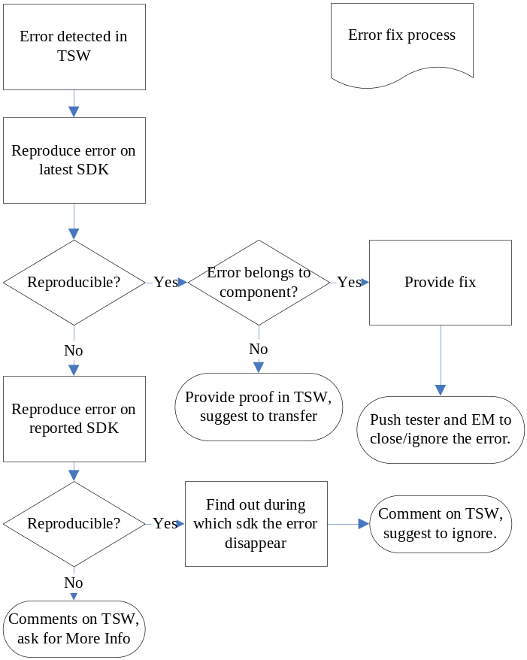
图需要改

5.2.2 Source code check in process
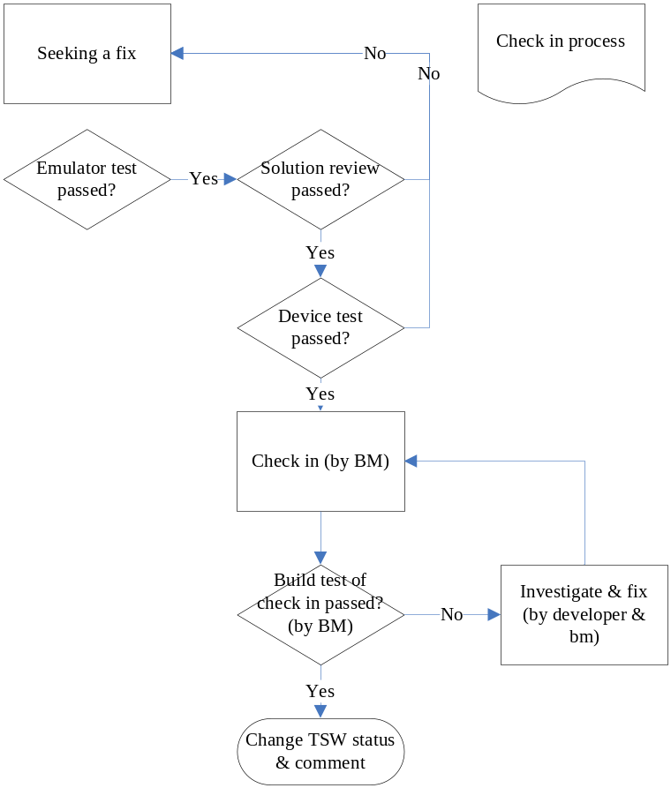

Tools and facilities for project work

Hardware
Nokia provides the terminals and corresponding SIM cards(according the Operators) to Neusoft.

Software
Neusoft will provide following software for this project
- Carbide/CodeWarrior
- RVCT
- Synergy client

Synergy Strategy
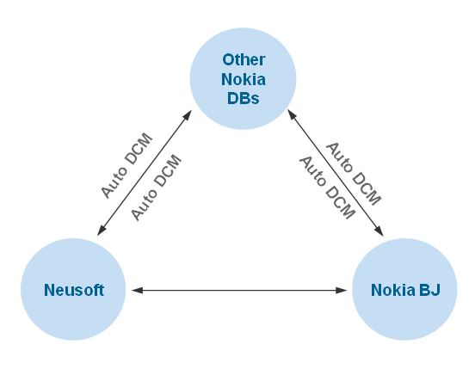

Nokia will provide
1. Networked Media App[Video Center]
- S60 SDK
- TSW
- QC

2. Mobile TV
- S60 SDK
- TSW
- QC

3. Video Player & Automate Test(MPX, MTP, MP)
- TSW
- QC
- STIF
- CodeScanner

4. Audio Application and Symbian MTP migration
- S60 SDK
- TSW
- QC

Current available in NEUSOFT
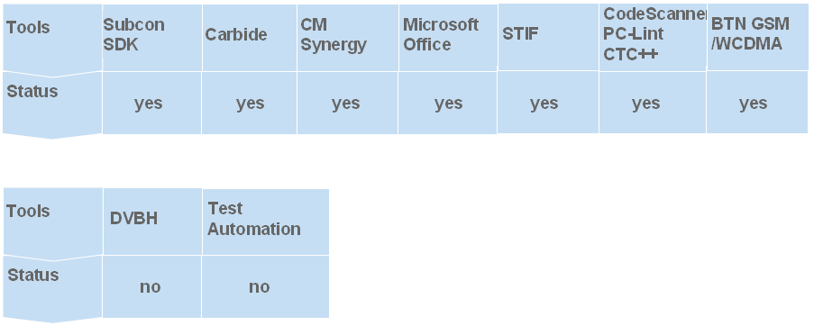

Network Environment

Neusoft Beijing
4M DDN for Data
HERE Berlin
看看Git是不是都是外网，不是的话还要看怎么连。
There is 4M DDN connected to Nokia extranet. Nokia 2G/3G base station has been already set up in Neusoft office. If the project need to use internal 2G/3G environment, Nokia will be responsible for provide NTN(Nokia Testing Network) cards for Neusoft.
Following Tools have been used in our current projects:
- Test Director/QC -- Filling the test results, based-web
- TSW – Error Database
- GITSynergy – Source code management

Source code management
Neusoft suggested to use Nokia Synergy to manage the source code. Nokia give the access right to Nokia Syngey system. Neusoft use Syngey client to access the source code.
根据文档内容要求，支持用Git做源代码管理工具。

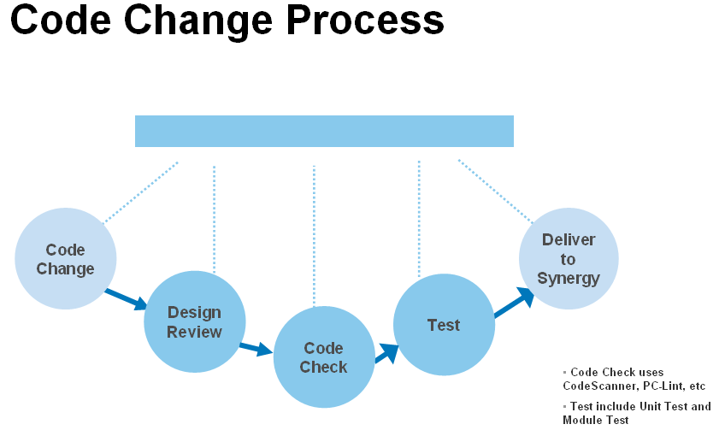

General Situations of Neusoft development work
For more info please refer to attachment: <<General Situations of Neusoft development work.doc>>
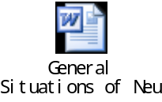

Project Plan & Schedule
Leo负责内容/Cindy整合。
客户要求：
Include a plan for starting this project. Outline when you could start and how long you think it will take to get familiar with the applications and the platform and become productive.
什么时间开始，多长时间熟悉。
熟悉时间根据工作量评估制定，东软开始时间7月初？

Resources
Leo负责内容/Cindy整合。
客户要求：
Provide a resource plan including how many resources you would allocate at minimum for the project time and how many resources you could allocate at maximum for a limited time if needed.
如何投入人
根据工作量评估，平均到2个月周期。

Pricing summary
Leo负责评估工作量，Cindy负责报价
客户要求：
Provide detailed and itemized pricing, including any costs which may apply.
报价
1,迁移对接账号
2,变更数据统计组件
3,修复Bug（如果想评估精确，需要客户提供详细列表）

诺基亚项目的测试工作量、文档工作量和沟通工作量要长于百度项目。
评估以百度项目评估模型为基础。

Statement of Work
Leo负责内容/Cindy负责整合。
客户要求：
Provide a Statement of Work that addresses any tasks to be completed as part of your proposed solution. Describe the proposed management structure and identify key personnel who will be assigned to this project. Suppliers shall designate key personnel deemed necessary to satisfy the requirement of this RFP. Resumes for all key personnel shall also be provided. Once identified, Suppliers may not change key personnel without prior notice and acceptance from HERE.

提供人员：
我，测试Leader，王凯，孙笑。
人员组成优势：各种技能包括、WP及地图经验丰富。缺点，诺基亚项目经验较少，是否需要补充？

Name | Gender | Age | Started work | Position
李享(Leo Lee) | Male | 28 | 2009 | Project Manager
 |  |  |  | Test Manager
王凯(Kai Wang) | Male | 32 | 2004 | Senior Dev
孙笑(Xiao Sun) | Male | 26 | 2010 | Senior Dev

Customer References
Cindy负责。
客户要求：
Provide appropriate and relevant lists of current customers and clients. Include dates, contact information, and a brief description of how they are using your products similar to this solution. These references may be contacted by telephone or email.

Name | Kai Wang |  | Gender | Male |  | Birthday |  | 4.12.1982
Education school |  | yangtze university |  |  | Major |  |  | Information and Computing Science Ics
Degree |  | Bachelor |  |  | Graduation date |  |  | 6.30.2004
Date of start work |  | 3.1.2005 |  |  | Position |  |  | Project Manager
Relevant project experience
The time periods |  | Project name |  |  |  |  |  |  | Position
3.8.2010-6.30.2012 |  | S60 Video Telephony |  |  |  |  |  |  | Senior Software Engineer
6.30.2012-10.30.2012 |  | baidu map WP7 |  |  |  |  |  |  | Senior Software Engineer
2012.12.1--2012.2.1 |  | Baidu Post Bar |  |  |  |  |  |  | Project Manager
Professional skills
C,C++ |  |  |  |  |  |  | 8 years
IOS,C# |  |  |  |  |  |  | 2 years

Name | Xue Jing |  | Gender | Female |  | Birthday |  | 09.11.1986
Education school |  | Chengdu University of Information Technology |  |  | Major |  |  | Electrical & Information Engineering
Degree |  | Bachelor |  |  | Graduation date |  |  | 6.30.2009
Date of start work |  | 7.1.2009 |  |  | Position |  |  | SW Developer
Relevant project experience
The time periods |  | Project name |  |  |  |  |  |  | Position
11.2012-3.2013 |  | Baidu Map Windows phone 8 |  |  |  |  |  |  | SW Developer
3.2012-6.2012 |  | News Templates Windows phone 7 |  |  |  |  |  |  | SW Developer
01.2012-3.2012 |  | Hub Framework Windows phone 7 |  |  |  |  |  |  | SW Developer
Professional skills
C# |  |  |  |  |  |  | 1 year
C++ |  |  |  |  |  |  | 4 years

Name | Leo Lee |  | Gender | Male |  | Birthday |  | 11.24.1985
Education school |  | University of Science & Technology ,Beijing |  |  | Major |  |  | Electrical & Information Engineering
Degree |  | Bachelor |  |  | Graduation date |  |  | 6.30.2009
Date of start work |  | 7.1.2009 |  |  | Position |  |  | Project Manager
Relevant project experience
The time periods |  | Project name |  |  |  |  |  |  | Position
11.25.2012-5.13.2013 |  | Baidu Map Windows phone 8 |  |  |  |  |  |  | Architect
11.11.2013-3.26.2014 |  | Baidu Wenku Windows phone 8 |  |  |  |  |  |  | Project Manager
4.15.2014-6.13.2014 |  | Sina News Windows phone 8 |  |  |  |  |  |  | Project Manager
Professional skills
C# |  |  |  |  |  |  | 5 years

Name | Sun Xiao |  | Gender | Male |  | Birthday |  | 11.17.1987
Education school |  | Shandong University of Science & Technology |  |  | Major |  |  | CST
Degree |  | Bachelor |  |  | Graduation date |  |  | 6.30.2010
Date of start work |  | 7.1.2010 |  |  | Position |  |  | Senior Development Engineer
Relevant project experience
The time periods |  | Project name |  |  |  |  |  |  | Position
11.25.2012-5.13.2013 |  | Sina WeiBo Windows phone 8 |  |  |  |  |  |  | Leader
9.1.2013-3.1.2014 |  | Baidu wenku Windows Phone 8 |  |  |  |  |  |  | Developer
11.1.2012-4.1.2013 |  | Baidu Map Windows Phone 8 |  |  |  |  |  |  | Developer
4.1.2012-10.31.2012 |  | Baihe Online Windows Phone 7 |  |  |  |  |  |  | Leader
Professional skills
C# |  |  |  |  |  |  | 5 years

